Celexon Folding Screen 366 x 206 cm

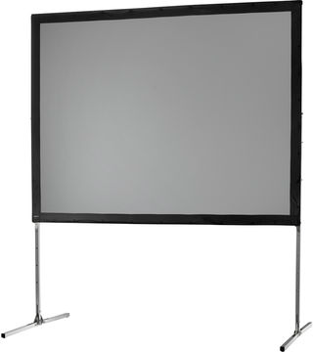

Canon XEED WUX5000 Projector
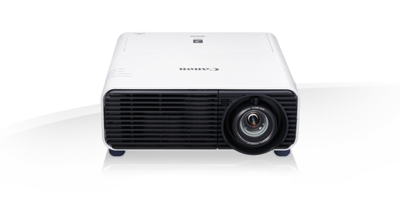

Sony BDP-S4500 Blu-Ray player
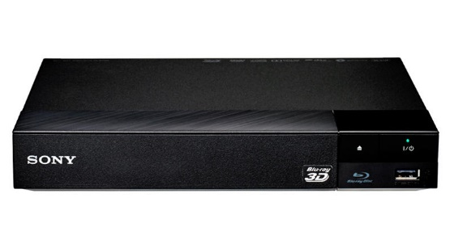

Dimensions (in flight case)
Width | 139cm
Height | 37cm
Depth | 41cm

Features
Aspect ratio | 16:10
Brightness | 5000 lumens
Zoom | 1.5x
Overall dimensions
WxHxD (mm) | 380 x 170 x 430
Weight | 8.5kg

Features
Connectivity | HDMI, USB
Playable format | Blu-Ray, DVD
Overall dimensions
WxHxD (mm) | 230 x 39 x 194
Weight | 0.8kg

Yamaha Stagepas 400i Amplifier and Speakers

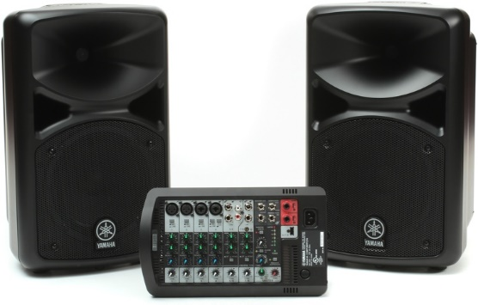

Further information can be found at:

Screen | http://uk.celexon.com/en/Mobile-screens/Folding-frame-screens/Mobile-Expert-front-projection.html
Projector | https://www.canon.co.uk/for_home/product_finder/multimedia_projectors/xeed/xeed_wux500/
Blu-Ray player | https://www.sony.co.uk/electronics/support/home-video-blu-ray-disc-players-recorders/bdp-s4500
PA | http://www.yamahaproaudio.com/global/en/products/pasystems/stagepas_400i600i/

Features
Output power | 60W
Frequency range | 55Hz-20kHz
Overall dimensions
WxHxD (mm) | Speaker 289 x 472 x 275  Mixer 308 x 180 x 116
Weight | 17.8kg (2 x Speaker 7.5kg + Mixer 2.8kg)

